Quinten Rader

CSC 340 Software Engineering and litercy

Requirements Specification Report

12/14/2018

Pharmacy Request System

Table of Contents

I. Introduction 3

A. Problem Statement 3

B. Proposal 3

II. System Description 3

III. System Requirements 3

A. Functional Requirements 3

B. Non-functional Requirements 10

IV. Use Case Diagram 12

V. Class Diagram 13

VI. Sequence Diagram 14

VII. State Diagram 18

VIII. Activity Diagram 19

IX. Data Base Design 19

A. ER Schema 19

B. Table Schema 19

X. Conclusion 19

XI. Data Dictionary 20

Table of Figures

Figure 1 Login Menu 3

Figure 2 User Logged In 4

Figure 3 Prescriptions received from the doctor 4

Figure 4 shows new refill request from patients 5

Figure 5 5

Figure 6 Showing all of the prescription requests 5

Figure 7 selects the prescription ID and changes the status 6

Figure 8 lets you see the patients details 6

Figure 9 lets you view each of the patients allergies 7

Figure 10 patients allergies being displayed 7

Figure 11 all prescription requests 8

Figure 12 patient can see their prescription is ready for pick up 8

Figure 13 displaying all notifications in the system 9

Figure 14 shows a new notification being created 9

Figure 15 invalid login 10

Figure 16 shows invalid input for change prescription status 10

Figure 17 Use Case Diagram 11

Figure 18 Class Diagram 12

Figure 19 Sequence Diagram - receive a refill request 13

Figure 20 Sequence Diagram - send pick up notice 13

Figure 21 Sequence Diagram - receive a new prescription 14

Figure 22 Sequence Diagram - send a notice to doctor 14

Figure 23 Sequence Diagram - receive a notice from doctor 15

Figure 24 Sequence Diagram - update prescription status 15

Figure 25 Sequence Diagram - checks patient records 16

Figure 26 Sequence Diagram - Log into user account 16

Figure 27 State Diagram 17

Figure 28 Activity Diagram – receive refill request 18

Figure 29 Activity Diagram - send pickup notice 18

Figure 30 Activity Diagram - Receive a new Prescription 19

Figure 31 Activity Diagram - Send a notice to a doctor 19

Figure 32 Activity Diagram - Receive a notice from a doctor 20

Figure 33 Activity Diagram - Update a status of a prescription 20

Figure 34 Activity Diagram - Checks patients records 21

Figure 35 Activity Diagram - Log in as user 21

# Introduction

## Problem Statement

This project is to implement a system that allows a pharmacy to provide basic services to its patients. The system will be a part of the doctor-patient system in your team project. The three subsystems should work together to provide doctors, patients, and pharmacies better services.

## Proposal

Make a system that will allow the pharmacy to provide basic services to its patients. The system will be part of the doctor-patient system in the team project. The three systems doctors, patients, and pharmacies will work together to provide everyone with better services.

# System Description

The pharmacy service system should be able to connect to the doctor-patient system. It will receive new prescriptions from doctors, receive refill requests from patients, check the basic information of patients (including their drug allergy record), display the status of a specified prescription/refill, and send a notice to a patient when his/her medicine is ready, and send/receive a notice to discuss a case with doctors.

# System Requirements

## Functional Requirements

1. Allow the user to log into the system. 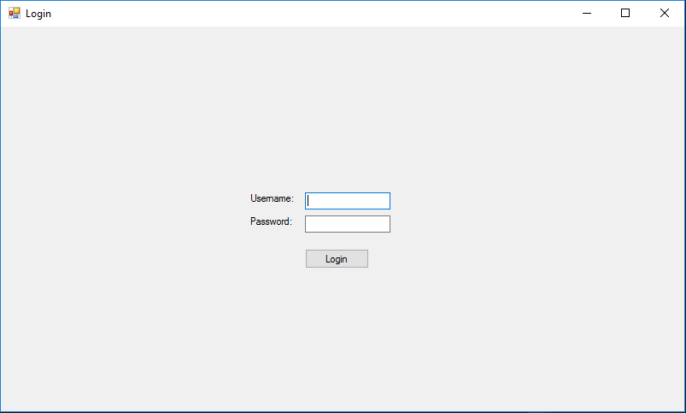

Figure 1 Login Menu

* 1. Let the user log into the system only when the correct credentials have been imputed.
  2. Log the user in. 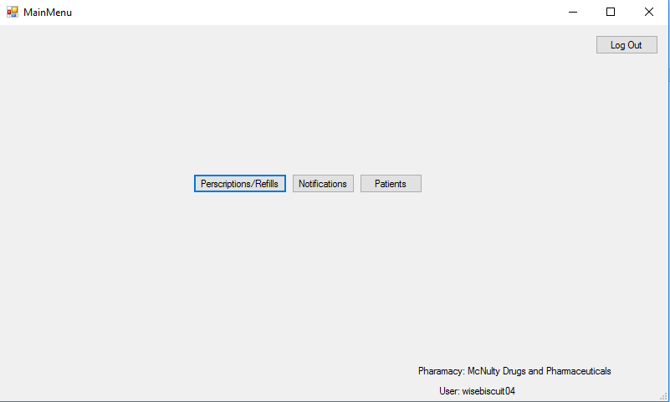

Figure 2 User Logged In

1. The system shall allow the pharmacy to receive a new prescription from a doctor.
   1. The system lets the user receive a notification from the doctor. 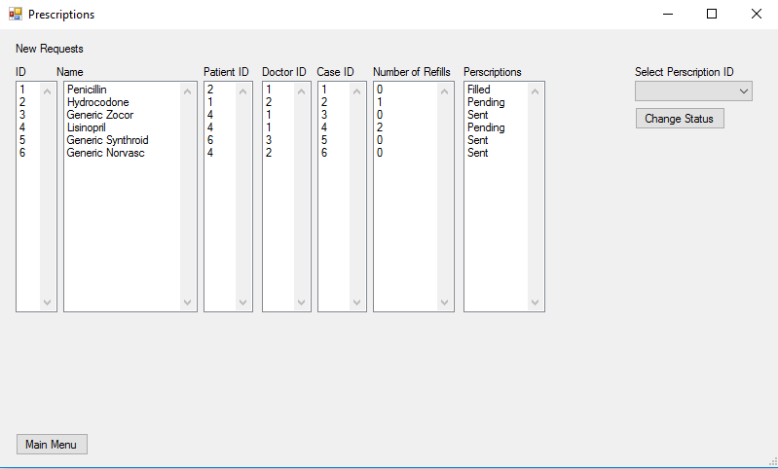

Figure 3 Prescriptions received from the doctor

1. The system shall allow a pharmacy to receive a refill request from a patient.
   1. The system allows the user to receive a new refill request from a patient

Figure 4 shows new refill request from patients

Figure 5

* 1. The system shall display the list of the requests.



Figure 6 Showing all of the prescription requests

* 1. The system shall let the pharmacy change a status of a specific request.

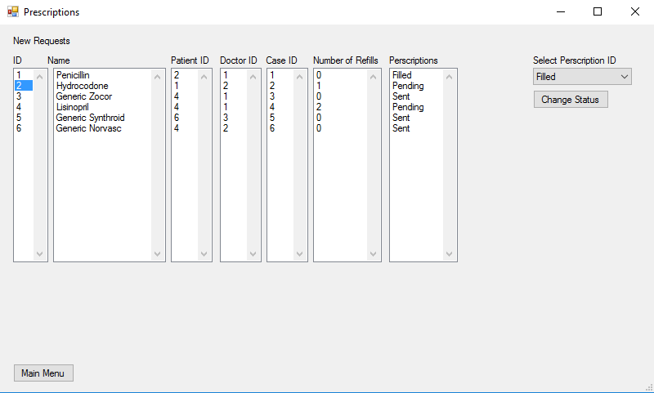

Figure 7 selects the prescription ID and changes the status

1. Check the basic information of patients (including their drug allergy record).
   1. The system shall let you see a list of all the patients.

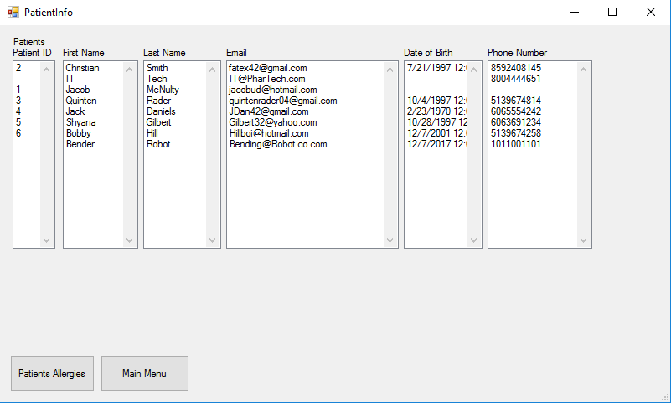

Figure 8 lets you see the patients details

* 1. The System will let you select a patient to see their drug allergies.

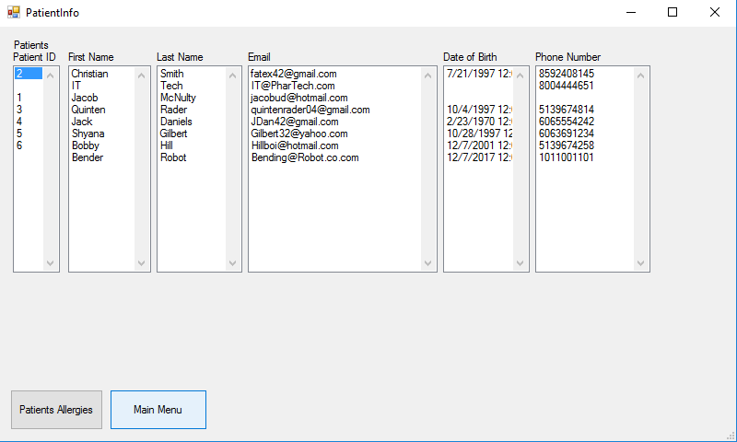

Figure 9 lets you view each of the patients allergies

* 1. The selected patient’s allergies are displayed.

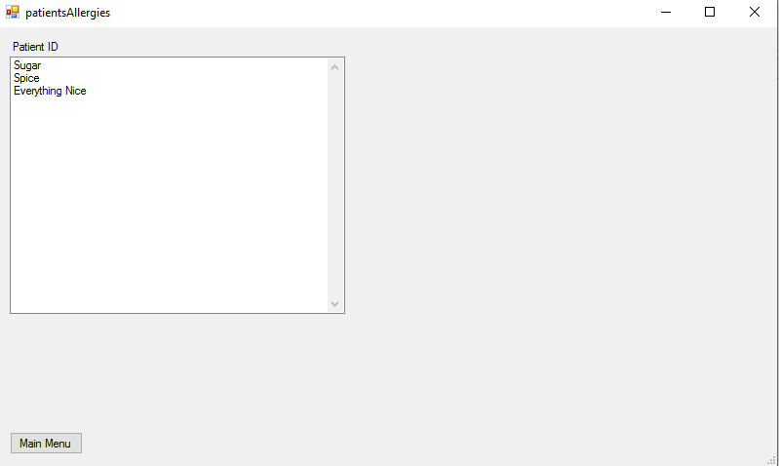

Figure 10 patients allergies being displayed

1. Display the status of a specified prescription
   1. This will allow the pharmacy to see all of the incoming prescriptions requests.

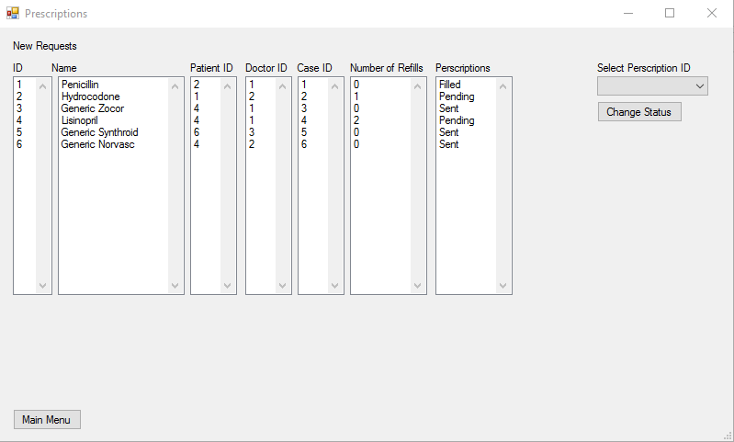

Figure 11 all prescription requests

1. This System will send a notice to a patient that his/her medicine is ready.

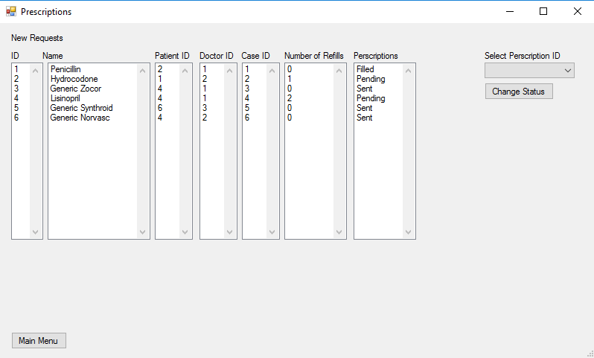

Figure 12 patient can see their prescription is ready for pick up

1. Send /receive a notice to discuss a case with doctors.
   1. This will allow the pharmacy to send a notice to the doctor that they need to discuss a case.

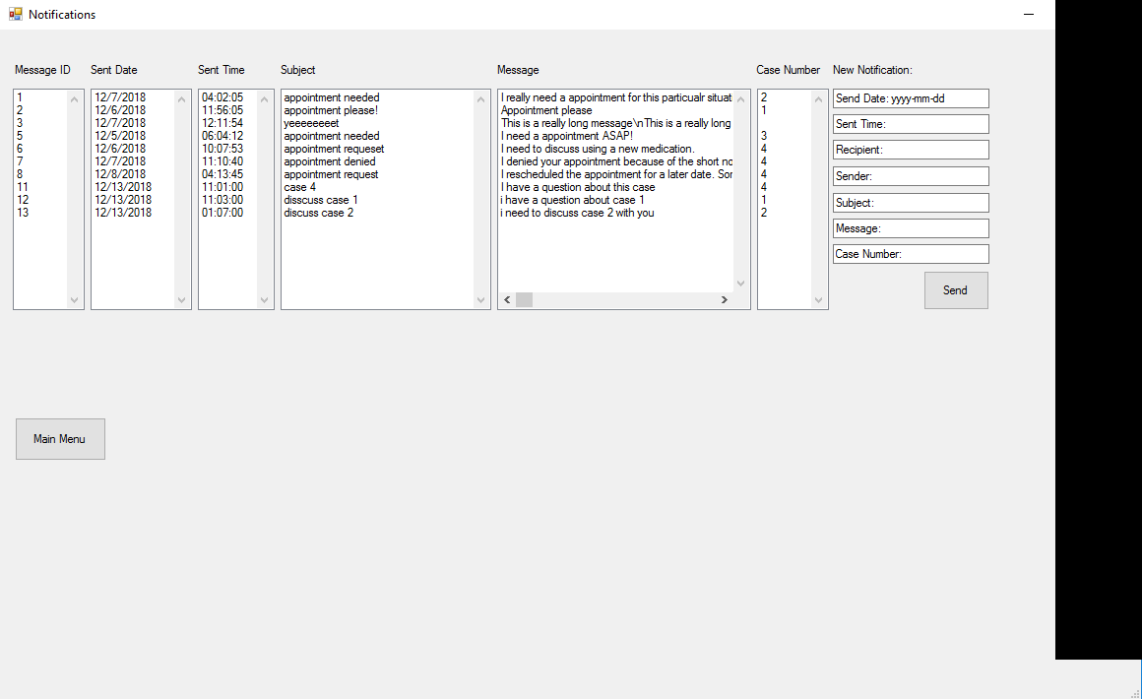

Figure 13 displaying all notifications in the system

* 1. Here the Pharmacy can see all the different notifications in the system.
  2. The pharmacy can fill out the information to send a notification to the doctor system that they need to discuss a case.

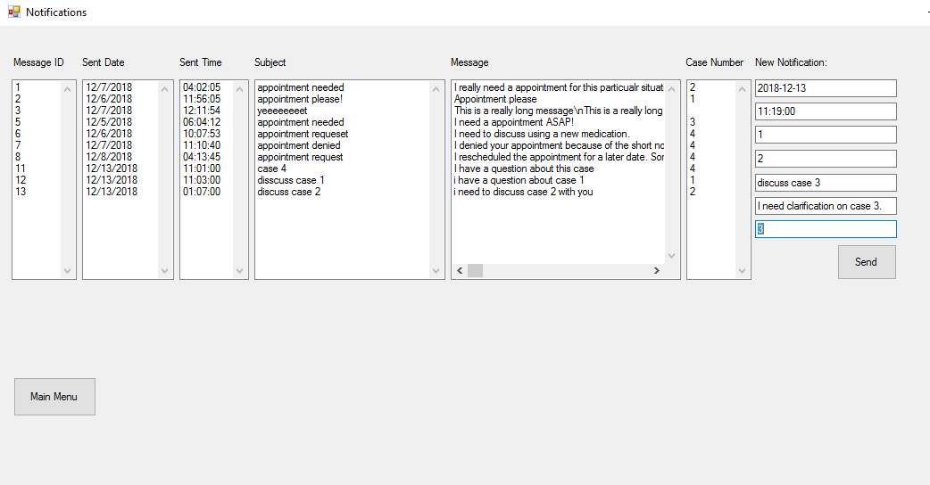

Figure 14 shows a new notification being created

* 1. The system then sends the notification to the doctor.

## Non-functional Requirements

1. Login information needs to match to a user that is associated with a pharmacy.

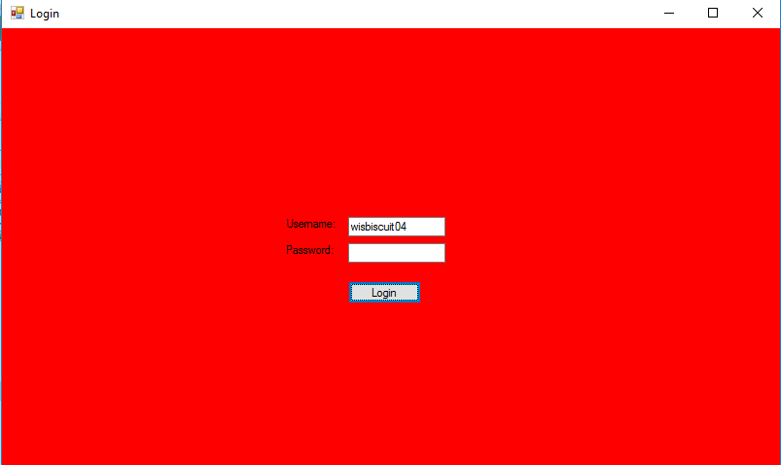

Figure 15 invalid login

1. The pharmacy cannot change a prescription/refill request without selecting the request ID or selecting the status change.

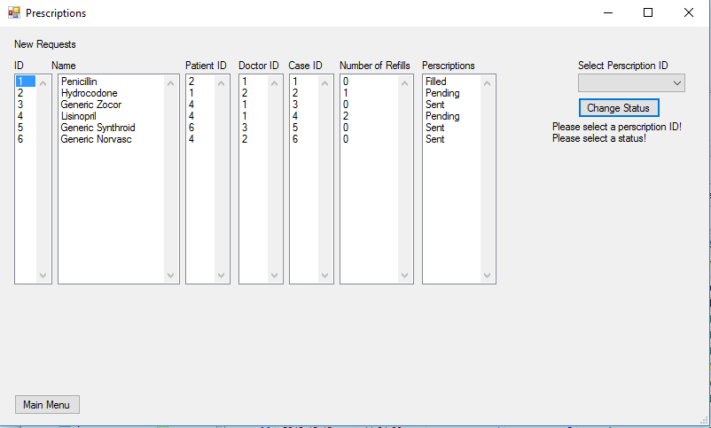

Figure 16 shows invalid input for change prescription status

# Use Case Diagram

PharmacyActor

PharmacyActor

Pharmacy Service System

Update

Prescription

Status

Check Patient

Record

Receive New

Prescription

Send Pickup

Notice

Receive Notice

from Doctor

Send Notice to

Doctor

Receive Refill

Request

Login user

Figure 17 Use Case Diagram

# Class Diagram

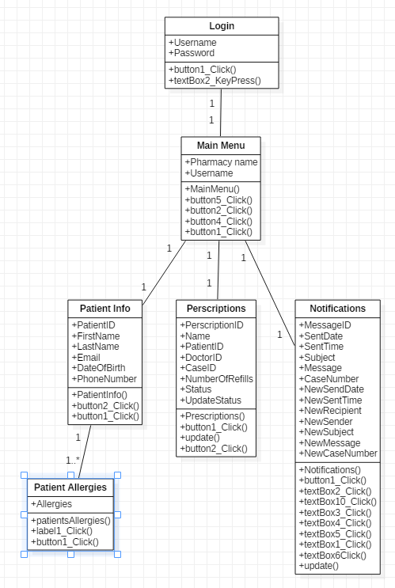

Figure 18 Class Diagram

# Sequence Diagram

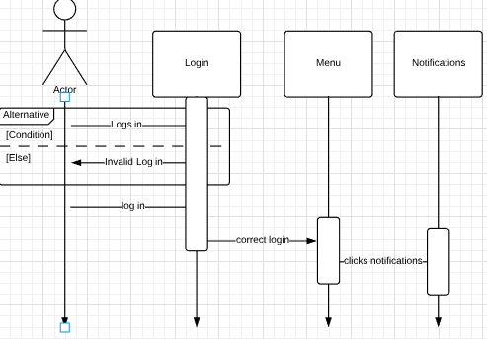

Figure 19 Sequence Diagram - receive a refill request

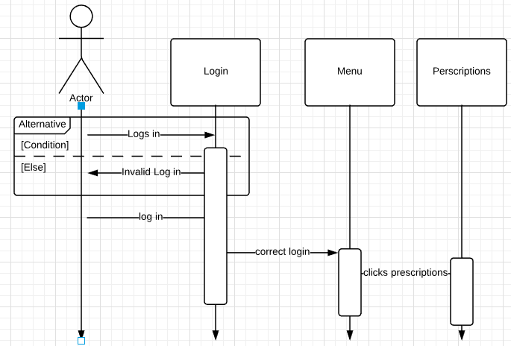

Figure 20 Sequence Diagram - send pick up notice



Figure 21 Sequence Diagram - receive a new prescription

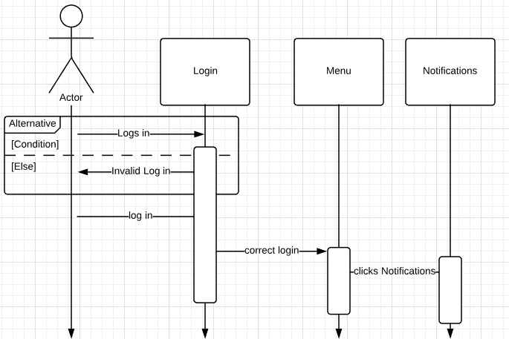

Figure 22 Sequence Diagram - send a notice to doctor



Figure 23 Sequence Diagram - receive a notice from doctor



Figure 24 Sequence Diagram - update prescription status

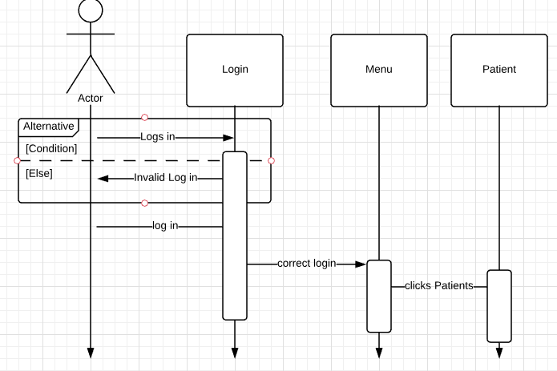

Figure 25 Sequence Diagram - checks patient records

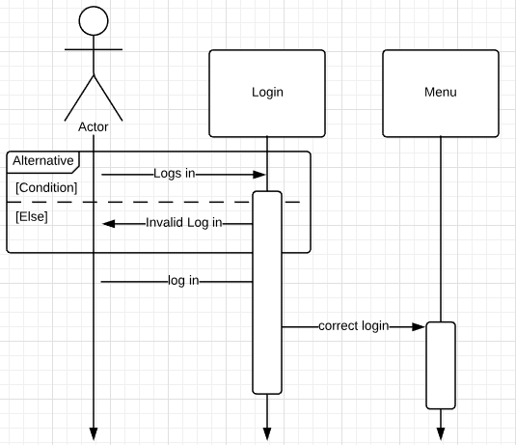

Figure 26 Sequence Diagram - Log into user account

# State Diagram

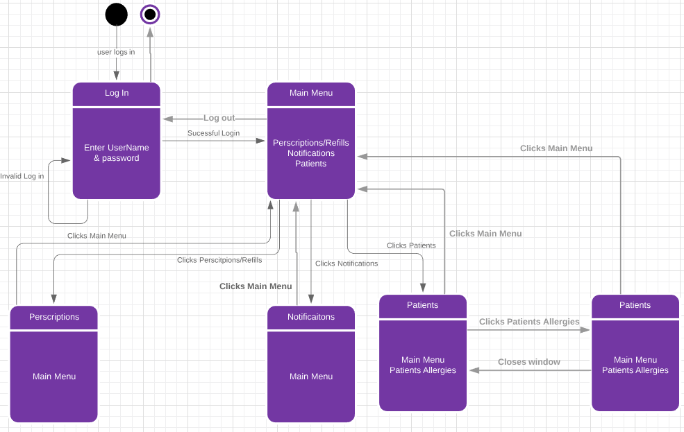

Figure 27 State Diagram

# Activity Diagram

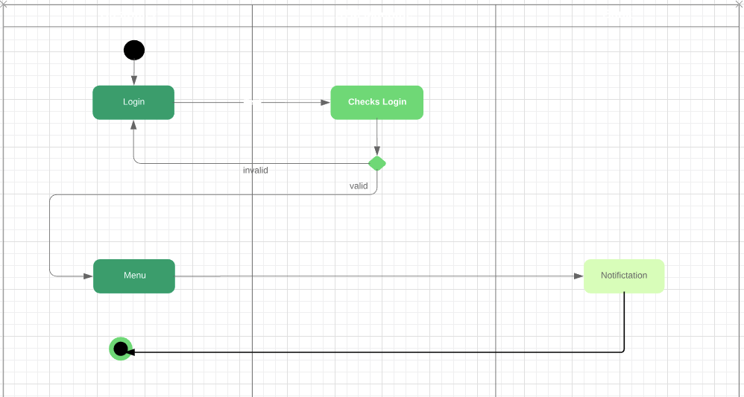

Figure 28 Activity Diagram – receive refill request

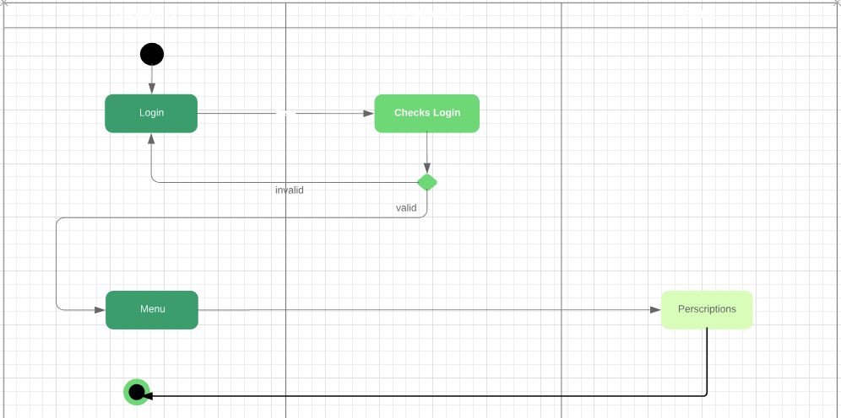

Figure 29 Activity Diagram - send pickup notice



Figure 30 Activity Diagram - Receive a new Prescription

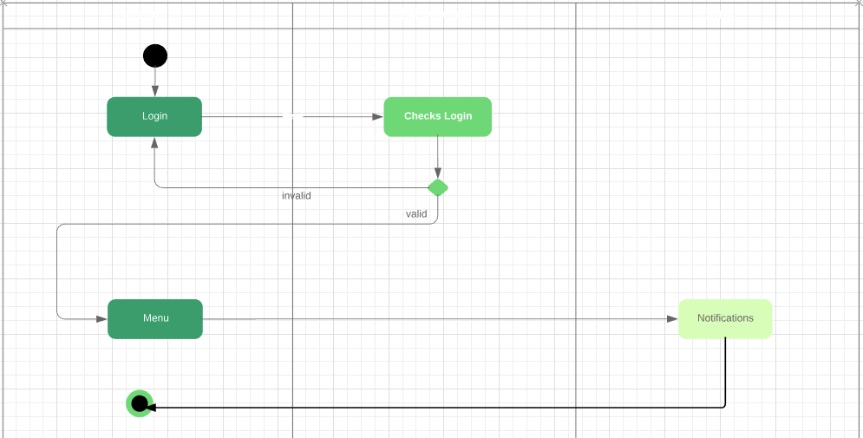

Figure 31 Activity Diagram - Send a notice to a doctor



Figure 32 Activity Diagram - Receive a notice from a doctor



Figure 33 Activity Diagram - Update a status of a prescription

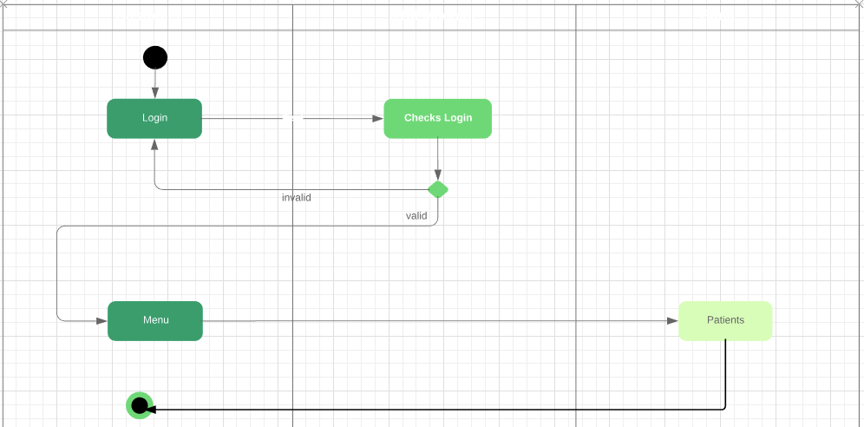

Figure 34 Activity Diagram - Checks patients records

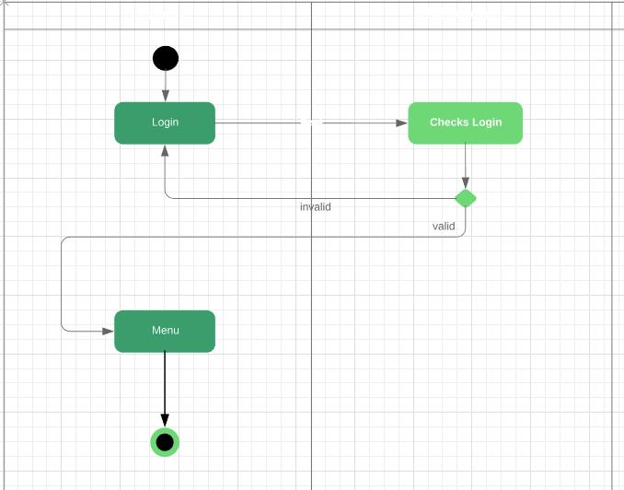

Figure 35 Activity Diagram - Log in as user

# Data Base Design

## ER Schema

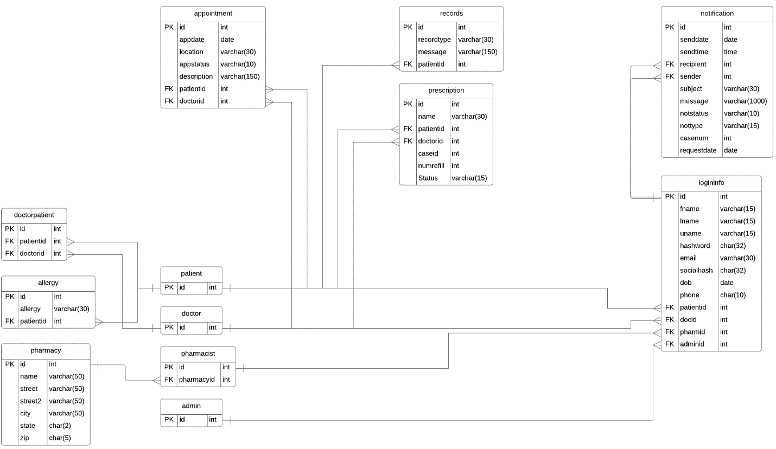

## Table Schema

1. Admin



1. Allergy

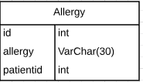

1. Appointment

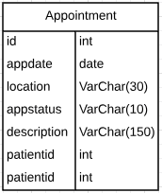

1. Doctor



1. DoctorPatient

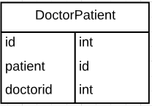

1. LoginInfo

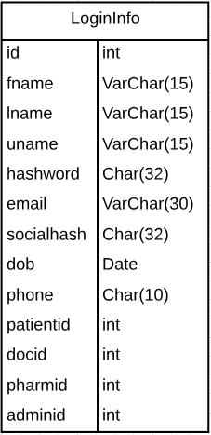

1. Notification

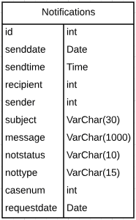

1. Patient



1. Pharmacist



1. Pharmacy

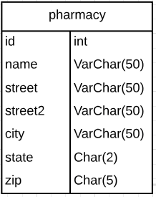

1. Prescription

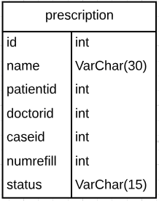

1. Records

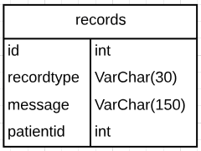

# Conclusion

In conclusion this system meets all of the requirements that the user requested plus a few more needed features. The user will receive new prescriptions from any doctor. The system can receive refill requests that patients sent to their pharmacy. The pharmacy can see the status of a specified prescription and/or refill. The pharmacy can send a notice to the patient when his or her medicine is received, ready to be picked up, or if it is a refill request they would be able to see if it was denied or cancelled. Next you can check the basic information of every patient using your pharmacy, this includes all of their known allergies. Lastly the pharmacy can send and receive a notice to discuss a case with a doctor. Some of the extra features that were not required but are very needed is the login menu. This will allow any pharmacist log into their pharmacy.

# Data Dictionary

|  |  |  |  |
| --- | --- | --- | --- |
| Attribute Name | Optional/Required | Attribute Type | Note |
| Adminid | Optional | Int | is the ID for admin |
| Dob | Required | Date | holds the date of birth of the patient |
| Docid | Optional | Int | is the ID for doctor |
| Email | Optional | VarChar(30) | holds the email for the patient |
| Fname | Required | VarChar(15) | holds the first name of the patient |
| Hashword | Required | Char(32) | contains the Hashword for the password |
| Id | Required | Int | is the ID for each login |
| Lname | Required | VarChar(15) | contains the patients last name |
| Message | Required | VarChar(1000) | holds the message for notifications |
| Notstatus | Required | VarChar(10) | is the notification status |
| Patientid | Optional | Int | is the ID for patient |
| Pharmid | Optional | Int | is the ID for pharmacy |
| Phone | Optional | Char(10) | Is the phone number for the patient |
| Recipient | Required | Int | Is the recipient of a sent message |
| Socialhash | Optional | Char(32) | Is the hash of the patients social |
| Senddate | Required | Date | Is the send date for a particular message sent |
| Sender | Required | Int | Stores the sender for a identifier |
| Sendtime | Required | Time | Stores the time the message was sent |
| Subject | Required | VarChar(30) | Stores the subject of the notification |
| Uname | Required | VarChar(15) | Stores the username of the user |